ONEWAY PREC BY DAW
/STATISTICS DESCRIPTIVES HOMOGENEITY WELCH
/PLOT MEANS
/MISSING ANALYSIS.

Oneway

Notes
Output Created |  | 05-May-2019 23:27:49
Comments
Input | Active Dataset | DataSet0
Input | Filter | <none>
Input | Weight | <none>
Input | Split File | <none>
Input | N of Rows in Working Data File | 30
Missing Value Handling | Definition of Missing | User-defined missing values are treated as missing.
Missing Value Handling | Cases Used | Statistics for each analysis are based on cases with no missing data for any variable in the analysis.
Syntax |  | ONEWAY PREC BY DAW  /STATISTICS DESCRIPTIVES HOMOGENEITY WELCH  /PLOT MEANS  /MISSING ANALYSIS.
Resources | Processor Time | 00 00:00:00.157
Resources | Elapsed Time | 00 00:00:00.167

[DataSet0]

Descriptives
 | N | Mean | Std. Deviation | Std. Error | 95% Confidence Interval for Mean
 |  |  |  |  | Lower Bound | Upper Bound
1-3 days a week | 12 | 30.8333 | 25.74643 | 7.43235 | 14.4748 | 47.1918
3-5 days a week | 5 | 35.0000 | 34.82097 | 15.57241 | -8.2359 | 78.2359
5-7 days a week | 13 | 60.7692 | 41.02063 | 11.37708 | 35.9807 | 85.5578
Total | 30 | 44.5000 | 36.42067 | 6.64947 | 30.9003 | 58.0997

Descriptives
 | Minimum | Maximum
1-3 days a week | .00 | 80.00
3-5 days a week | 5.00 | 95.00
5-7 days a week | 5.00 | 130.00
Total | .00 | 130.00

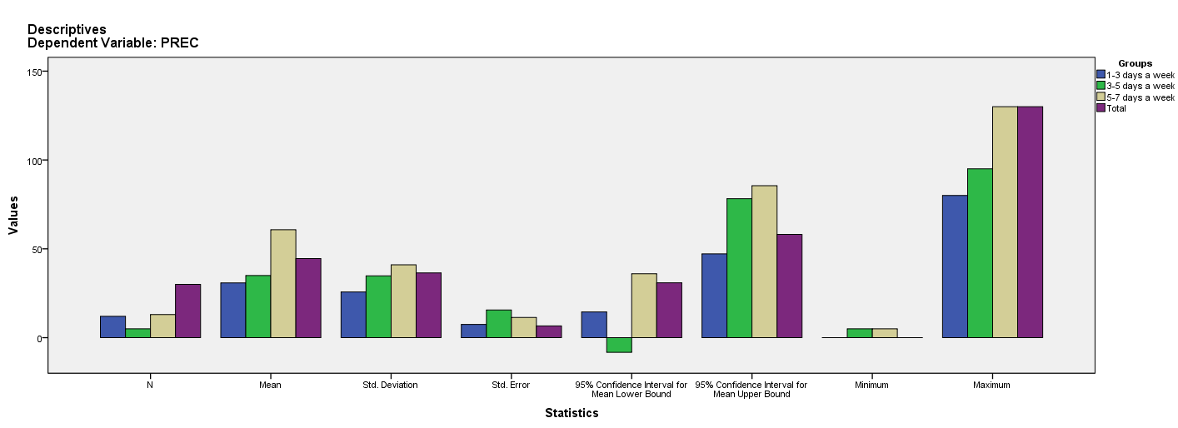

Test of Homogeneity of Variances
PREC
Levene Statistic | df1 | df2 | Sig.
.604 | 2 | 27 | .554

ANOVA
PREC
 | Sum of Squares | df | Mean Square | F | Sig.
Between Groups | 6133.526 | 2 | 3066.763 | 2.561 | .096
Within Groups | 32333.974 | 27 | 1197.555
Total | 38467.500 | 29

Robust Tests of Equality of Means
PREC
 | Statisticª | df1 | df2 | Sig.
Welch | 2.324 | 2 | 10.839 | .145
a. Asymptotically F distributed.

Means Plots

